|  |  |
| --- | --- |
|  | *Deploy EventHubSender to Azure App Service using Visual Studio Code* |

**FACTS**

|  |  |
| --- | --- |
| Size: | n/a |
| Software: | ArcGIS Velocity, ArcGIS GeoEvent Server |
| Application/Extension: | n/a |
| Database: | n/a |
| Other Software Required: | Azure Portal, Azure Event Hub, Microsoft Visual Studio Code, Azure App Service extension for VS Code, Git |
| Platforms Tested: | Windows 10, Mac OS X |
| Special Functionality: | Azure App Service |
| Audience: | Industry and sales teams |

**PURPOSE**

EventHubSender is a C#.Net console app that can be configured and run to send event messages to an Azure Event Hub. Intended to be deployed to an Azure portal as an Azure WebJob running in an App Service to support real-time demonstrations for Velocity, the app provides a simulated stream of event messages in an Event Hub so that Velocity or GeoEvent Server can ingest them as a feed.

Subsequently users outside the Real-time and Big Data team have needed demo resources to be more widely and frequently available and have seen value in being able to host industry-specific demo data feeds using this app. These instructions will guide you through the process of deploying your own EventHubSender app to support your industry demos of Velocity and GeoEvent Server. Specifically, it will lead you through the following steps:

* Set up your deployment environment
* Clone the EventHubSender app
* Configure it to use your demo simulation data and Event Hub
* Create an App Service resource to host the EventHubSender app
* Deploy your EventHubSender to your App Service

**DATA SOURCES AND DESCRIPTION (Refer to Data Distribution Permission statement at the end of this document)**

For this demo resource one csv file is hosted in an Amazon Web Service (AWS) S3 bucket which you may use to set up your EventHubSender. This is provided for illustrative purposes only and we generally expect most users will replace our sample csv file with their own simulation data:

1. **Gather your deployment resources**

You’ll need:

* + - An Azure account with an active subscription. [Create one for free](https://azure.microsoft.com/free/?utm_source=campaign&utm_campaign=vscode-tutorial-appservice-extension&mktingSource=vscode-tutorial-appservice-extension).
    - An Azure Event Hub. If you don’t already have one [create your first one](https://docs.microsoft.com/en-us/azure/event-hubs/event-hubs-create).
    - Visual Studio Code (VS Code) installed on your local machine. [Get it here](https://code.visualstudio.com/).
    - The Azure App Service extension for VS Code ([Get it here](https://marketplace.visualstudio.com/items?itemName=ms-azuretools.vscode-azureappservice) or install from within VS Code)
    - Git installed on your local machine. [Get it here](https://git-scm.com/).
    - A delimited text file of events you wish to simulate. It must be hosted in a place where it is accessible by URL such as an Amazon S3 bucket or GitHub repo. To get started you may use the sample file hosted at https://a4iot-test-data.s3.us-west-2.amazonaws.com/point/Charlotte_Simulations/Buses_in_CharlotteNC.csv

1. **Sign in to Azure in VS Code**

If you already use the Azure service extensions, you should already be logged in and can skip this step. If you don't use the Azure service extensions, continue in this section to install it.

* 1. 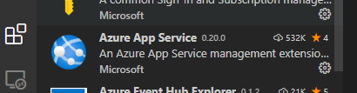In VS Code click **View > Extensions**
  2. In the search bar type **Azure App Service**
  3. Click **Install** on the Azure App Service extension

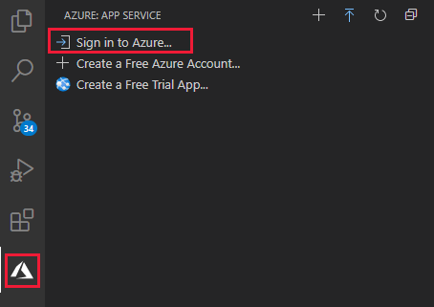Once you've installed the Azure App Service extension in VS Code, you need to sign into your Azure account by navigating to the **Azure** **Explorer**, select **Sign in to Azure**, and follow the prompts. (If you have multiple Azure extensions installed, select **App Service**.)

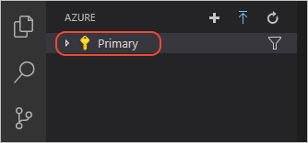VS Code status bar showing Azure accountAfter signing in, verify that the email address of your Azure account (or "Signed In") appears in the Status Bar and your subscription(s) appears in the Azure Explorer:

1. **Clone the event-hub-sender repo**

Create the app by cloning a Git repository. Two methods for doing so are illustrated below.

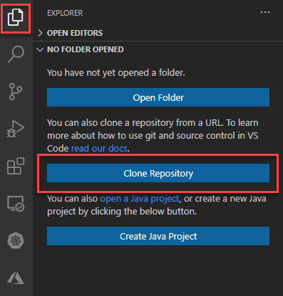Method 1: Use Git in VS Code:

* + 1. In VS Code, select the explorer icon to open the Files and Folders Explorer, then click **Clone Repository**
    2. Paste **https://github.com/ArcGIS/event-hub-sender** into the search bar and click ‘**Clone from URL https://github.com/ArcGIS/event-hub-sender**’
    3. Navigate to the folder where you will save the cloned application files and click **Select Repository Location**.

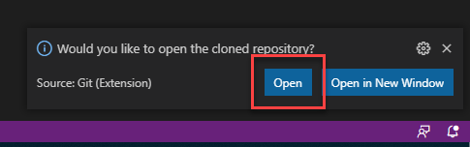

* + 1. Click **Open**.
    2. 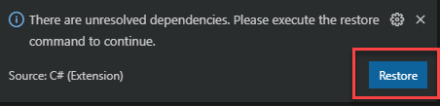If a message appears indicating unresolved dependencies click **Restore**.
    3. The application files appear in the **Files and Folders Explorer**.

Method 2: Use Git directly:

* + 1. Open a terminal command prompt and change directories to the location where you want to create the app folder.

Or

* + 1. In Windows Explorer in the folder where you want to create the app, right click and click **Git Bash Here** to open a Git Bash command window.
    2. Enter the following git command in the terminal or Git Bash window to clone the repository:

**git clone https://github.com/kengorton/event-hub-sender**

* + 1. Change into the new *eventhubsender* directory by running the following command:

**cd eventhubsender**

* + 1. Install the application's dependencies by running the command:

**npm install**

* + 1. Start VS Code with the following command:

**code .**

1. **Update app.config to reflect your Event Hub and simulation file**

For this step you’ll need the connection string for your Event Hub. To obtain this:

* 1. 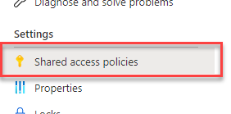In your Azure portal go to your Event Hubs namespace, select your Event Hub and open **Shared access policies**.

Shared access policies expose any of three access capabilities: Manage, Send and Listen. In order to send events to an Event Hub EventHubSender must use a policy with at least Send capabilities. In order to receive events from an Event Hub, Velocity or GeoEvent Server must use a policy with at least Listen capabilities. Creating a policy with both Send and Listen allows you to use the same connection string for your EventHubSender app as well as for an Azure Event Hub feed in Velocity or GeoEvent Server. Alternately you can create separate policies for each.

* 1. Perform the following steps i-v only if you need to create a new shared access policy. Otherwise go to step 3. In the Shared access policies list:
     + 1. click the **Add** button,
       2. 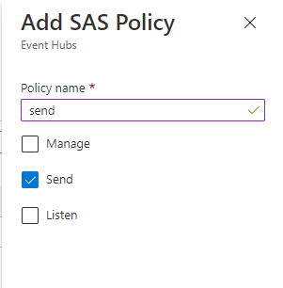enter a policy name
       3. check **Send** to allow your EventHubSender app to send messages to the Event Hub.
       4. Check **Listen** to allow you to use the connection string for this policy to set up an Azure Event Hub feed in Velocity or an Azure Event Hub input GeoEvent Server.
       5. Click **Create** at the bottom of the panel.
  2. Select the policy you wish to use and copy the **Connection string-primary key** to your system clipboard.

The app.config file in the EventHubSender code files contains a set of key/value pairs that the app uses to initialize settings for your deployment. You will need to update some of the values in this file in order to configure the app for your needs.

* 1. In VS Code’s **File and Folders Explorer** click app.config to open the file in the VS Code editor.

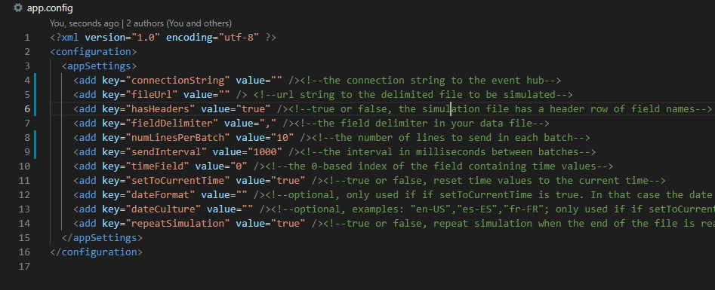

* 1. Enter or update values for the keys as follows:
     + connectionString – In the empty quotes after ‘value=’ paste the complete connection string you copied above..
     + fileUrl – Enter the URL to the simulation delimited file containing the data to be sent. If using our sample file, set this value to “**https://a4iot-test-data.s3.us-west-2.amazonaws.com/point/Charlotte_Simulations/Buses_in_CharlotteNC.csv”**.
     + hasHeaders – Enter true or false to indicate whether the simulation csv file has a header row of field names. If using our sample csv file, set this value to **“true”**.
     + fieldDelimiter – the delimiter between fields in the simulation file. If using our sample csv file, set this value to **“,”**.
     + numLinesPerBatch – Enter the number of lines to send with each batch. The app will read this number of lines from the simulation csv file, bundle them into a batch of events and send them to the Event Hub all at once. Then it will read the next set of lines into a batch, send them and repeat until the end of the simulation csv file is reached and all lines have been sent. You might set this value to be equal to the number of unique track ids in your data or use it in conjunction with the sendInterval to simply control the rate of events into your Event Hub. If using our sample csv file, there are **57** unique track ids.
     + sendInterval – Enter the number of milliseconds between batches sent to the Event Hub. This time includes the time required to send a batch. Thus, if this value is set to 1000ms, and it takes 700ms to send a batch, the app will wait 300ms before sending the next batch. If it takes longer than this value to send a batch, it will not wait before sending the next batch.
     + timeField – The zero-based index of the field in the simulation csv file containing date values. If using our sample csv file, set this value to **“0”**.
     + setToCurrentTime – Enter true or false to indicate whether to update the values in the date field to the date and time the event is sent to the Event Hub. If using our sample csv file, set this value to “**true”**.
     + dateFormat – Optional, only used if setToCurrentTime is true. In that case the date values will be formatted as strings according to this formatter. If this value is empty, date values will be epochs. Formatting string can be standard or custom. See <https://docs.microsoft.com/en-us/dotnet/standard/base-types/standard-date-and-time-format-strings> and <https://docs.microsoft.com/en-us/dotnet/standard/base-types/custom-date-and-time-format-strings>
     + dateCulture - Optional, examples: "en-US", "es-ES", "fr-FR"; only used if setToCurrentTime is true and dateFormat is not empty. In that case date strings will be formatted according to the culture specified in this setting or the default culture if empty
     + repeatSimulation – Enter true or false to indicate if the app, upon reaching the end of the simulation csv file, should return to the top of the file and repeat the simulation.
  2. Click File > Save.

1. 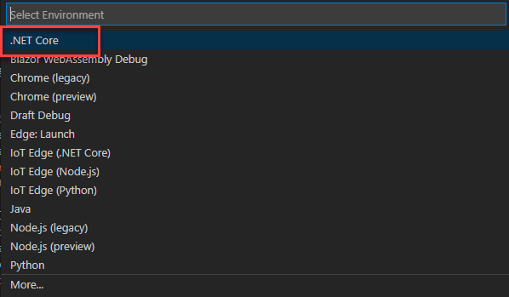**(Optional) Run your local EventHubSender app**
2. In VS Code click Run > Start Debugging.
3. If a message appears prompting you to select an Environment, select **.NET Core**.

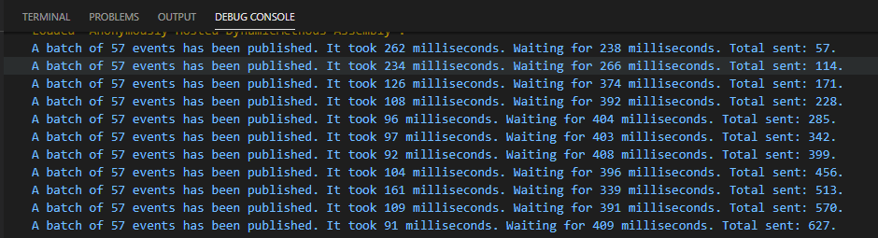After a pause while the app initializes and loads in the simulation file you configured, in the VS Code Debug Console you should see a scrolling list of messages indicating that the app has sent messages to your Event Hub in the format “A batch of <<*numLinesPerBatch*>> events has been published. It took *n* milliseconds. Waiting for <<*sendInterval* - *n*>> milliseconds. Total sent: <<*numLinesPerBatch* * number of batches sent>>.

1. **Commit changes in the app.config file to the local repo**

Having edited the app.config file, you must commit the changes to your local repository so that they will be reflected in the published App Service.

1. Open the Source Control explorer.
2. 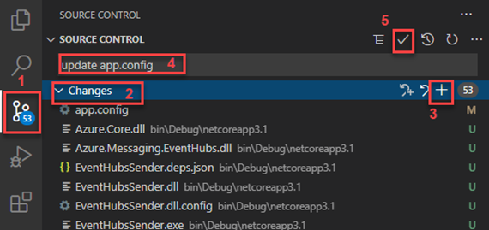Select the Changes list.
3. Click the **+** button to stage all changes for a commit.
4. Enter a comment such as “updated app.config” to indicate the reason for the commit.
5. Click the checkmark button  to commit the changes.
6. **Create App service resource in VS Code**
7. From the command palette (**Ctrl**+**Shift**+**P** on Windows**, Cmd**+**Shift**+**P** on Mac), type "create web" and select **Azure App Service: Create New Web App...Advanced**. You use the advanced command to have full control over the deployment including resource group, App Service Plan, and operating system rather than use Linux defaults.
8. 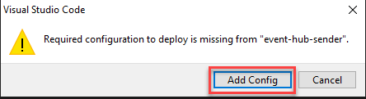If a message appears indicating a required configuration to deploy is missing, click **Add Config**.
9. Respond to the prompts as follows:
   * Select your **Subscription** account.
   * For **Enter a globally unique name**, enter a name that's unique across all of Azure. Use only alphanumeric characters ('A-Z', 'a-z', and '0-9') and hyphens ('-')
   * Select **Create new resource group** and provide a name like EventHubSender-rg.
   * Select the **.Net Core 3.1 (LTS)** runtime stack.
   * Select an operating system (Windows or Linux).
   * Select **Create a new App Service plan**, provide a name like EventHubSender-plan, and select any [pricing tier](https://docs.microsoft.com/en-us/azure/developer/javascript/core/what-is-azure-for-javascript-development#free-tier-resources). The app will incur costs on any pricing tier other than **F1 Free**.
   * Select **Skip for now** for the Application Insights resource.
   * Select a location near you or where you want the app to run.

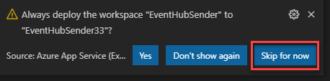If a message asks to ‘Always deploy the workspace EventHubSender to ‘ this App Service click **Skip for now**.

1. 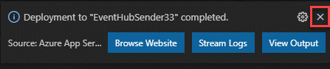After a short time, VS Code notifies you that creation is complete. Close the notification with the **X** button:
2. 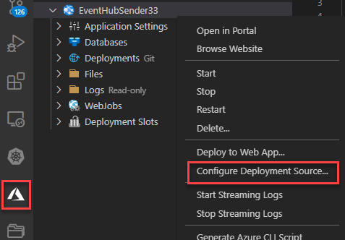With the web app in place, you next instruct VS Code to deploy your code from the local Git repo. Select the Azure icon to open the **Azure App Service** explorer, expand your subscription node, right-click the name of the web app you just created, and select **Configure Deployment Source**.
3. When prompted, select **LocalGit**.

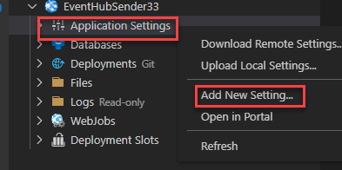If deploying to an App Service on Windows, you need to create an additional setting before deployment:

1. In VS Code, expand the node for the new App Service, right-click **Application Settings**, and select **Add New Setting**:
   1. 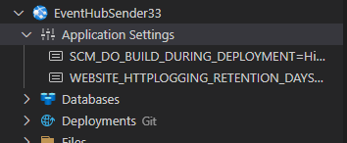Enter **SCM_DO_BUILD_DURING_DEPLOYMENT** for the setting key and **1** for the setting value. This setting forces the server to run npm install upon deployment.
   2. Expand the **Application Settings** node to verify the setting is in place.
2. Select the blue up arrow icon to deploy your code to Azure:
3. At the prompts, select your **subscription** account again and then select the name of the web app created earlier.
4. If a message appears about uncommitted change(s) in your local repo, click **Deploy Anyway**.
5. When deploying to Linux, select **Yes** when prompted to update your configuration to run npm install on the target server.
6. If a message asks to ‘Always deploy the workspace EventHubSender to‘ this App Service click **Skip for now**.

Congratulations. You have deployed an Azure App Service and WebJob that continuously sends event messages to your Azure Event Hub. You can now configure a feed in Velocity using the Azure Event Hub feed type or an input in GeoEvent Server using the Azure Event Hub connector. You will need the connection parameters that are contained in an Azure Shared access policy connection string. If the connection string you used in this procedure has Listen configured, you can use it in your Velocity feed. Otherwise go back to your Event Hub and get the connection string for a policy that has Listen configured.

#### DATA Distribution Permission

Esri – the sample data and related material(s) may be used for **Esri internal use only**:

_X_ Demonstrations/Benchmarks

_X_ Trade Shows/Esri User Conferences

_X_ Esri World Wide Web

_X_ Esri Educational/Training Materials

_X_ General Marketing, Advertising, and Promotion (i.e. brochures, slides, videos, etc.)

Esri Domestic Business Partners – the sample data and related material(s) may be forwarded to Esri Business Partners for:

_X_ Demonstrations/Benchmarks

_X_ Trade Shows/Esri User Conferences

Esri International Distributors – the sample data and related material(s) may be forwarded to Esri International Distributors for:

_X_ Demonstrations/Benchmarks

_X_ Trade Shows/Esri User Conferences